Installing Ruby

Installing Ruby on Ubuntu GNU/Linux
Okay, you need to install a thing called RVM (ruby version manager) which will control which version you are using. Why? Its because ruby version changes fast. Before you had 1.8, now 1.9 and soon ruby 2 will be out. Apart from just using ruby, you will also use it for other stuff like web development like Sinatra and Ruby on Rails. You might need to change from one version to other without uninstalling and reinstalling ruby again and again. RVM manages this for you. With simple commands we can switch between Ruby versions easily.
Installing RVM :
OK, to install RVM, you needto make sure you have the necessary libraries to compile and install it. So copy the stuff below, (omitting the starting $) and paste it into terminal
If you are using the PDF version of this book, copying and pasting these codes will result in an error, so I have put all the codes in this file ruby_install.bash , use it to avoid tedious typing
$ sudo apt-get install build-essential bison openssl libreadline6 libreadline6-dev curl git-core zlib1g zlib1g-dev libssl-dev libyaml-dev libsqlite3-0 libsqlite3-dev sqlite3 libxml2-dev libxslt-dev autoconf libc6-dev ncurses-dev automake
Now install RVM using the following command
$ curl -L https://get.rvm.io | bash -s stable --ruby

Once done give these commands into terminal. These will tell Ubuntu GNU / Linux where to find the ruby interpreter.
$ echo '[[ -s "$HOME/.rvm/scripts/rvm" ]] && . "$HOME/.rvm/scripts/rvm" # Load RVM function' >> ~/.bashrc

$ source ~/.bashrc
Once done, possibly restart computer and in terminal type the following
$ ruby -v
It will spit an output somethin like this
ruby 1.9.3p194 (2012-04-20 revision 35410) [x86_64-linux]
Then all is OK!

Installing on Windows
WHAT? U think I am insane to use Windows now?

Installing on Mac
Beauty is just skin deep. Only stupids will get seduced by it. If you are using mac, break free from it and try out GNU/Linux which is rock solid and DRM free.

Installing IDE
You need a good IDE (Integrated development environment) to get started with Ruby. I recommend simple and light weight IDE Geany. In Ubuntu machine just type
sudo apt-get install geany
for the IDE to get installed. If the system asks for administrator password, provide it.
Click the dash button and type in geany. Click on the geany icon, you will get it :-)
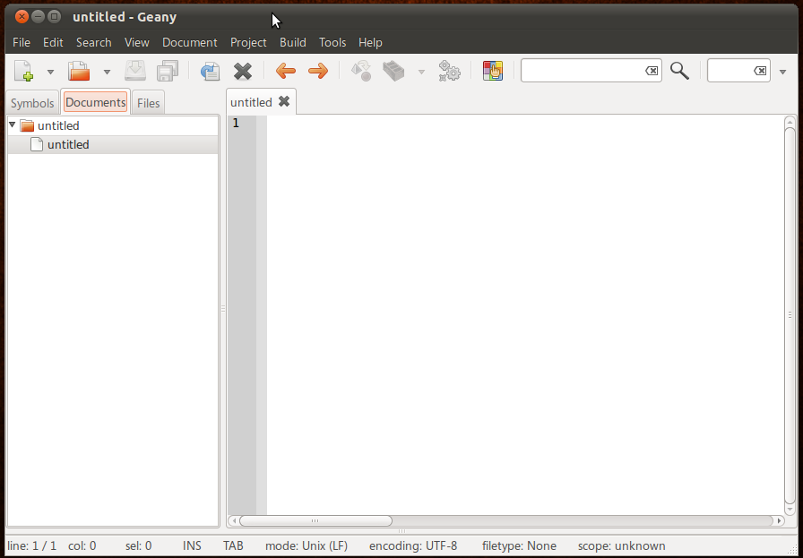

Windows users goto http://www.geany.org/ to download the installer

